**Dominicks Visuals**

Author: Jose Manuel Alvarez Gonzalez

Email Id: jmanuel.ag89@gmail.com

Date: 28/10/2023

# Introduction

In this assignment, we work with Dominick's Finer Food Database, spanning 1989 to 1997 across their store chain, primarily focusing on the "Cheese" category using two datasets:

1. **Movement File:** Weekly sales reports for items across all stores, including total items sold, quantities, and gross profit percentages per item.
2. **Shops File:** Categorical information about each store, such as price tier and zone affiliations, sourced from Dominick's Data Manual.

Our data preparation involved meticulous cleaning, resulting in a final dataset with 86 stores, 399 weeks, and 660 cheese products. To enhance interpretability, we created aggregates for weekly sales and profits, both at the store and price tier levels.

Our visualizations aim to reveal sales and profit dynamics over time, identifying peaks, troughs, and seasonality. We delve into granular analysis, dissecting sales and profits by price tier and conducting comparative assessments of all stores. Through this exploration, we seek to extract insights into the cheese category's intricate dynamics in Dominick's retail landscape from 1989 to 1997.

# Graphic 1

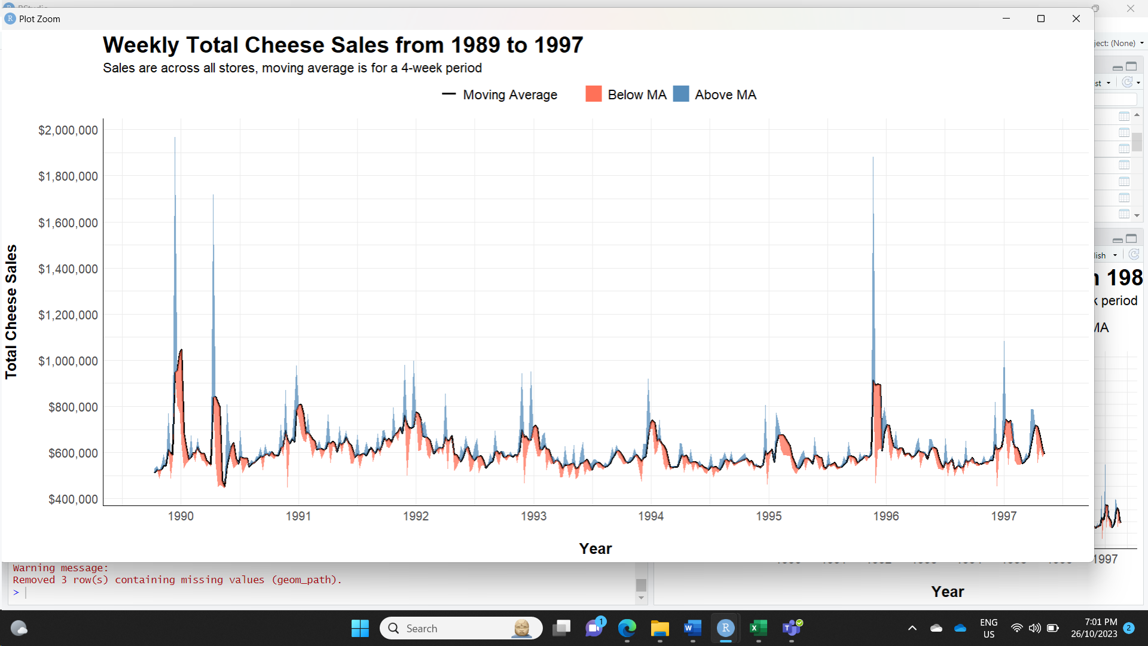

Figure , Time series for weekly cheese sales

|  |  |
| --- | --- |
| **Design information** | **Questions of interest and conclusion** |
| **Type of graphic:**  Time series line chart with ribbons  **Invariant:** Cheese Products  **Components:** Weekly cheese sales (Q) Week (O)  **Imposition:** Orthogonal  **Planar variables:** Week (x-axis), Total Cheese Sales (y-axis)  **Retinal variables:** Position Colour used for distinguishing "Above MA" and "Below MA"  **Schematic** Subtitle helps identify the period of Moving Average | **Can we identify any seasonality on the sales?**  **Are there instances where weekly sales significantly deviate from the moving average?**  **Are the sales increasing with time?**  We can identify how the cheese sales tend to reduce during the middle of the year, which is the warmer times of the year. Just before the end of the year we can find high sales peaks, which might be do Christmas. Total sales tend to be quite stable during the 9 year period. |

# Graph 2

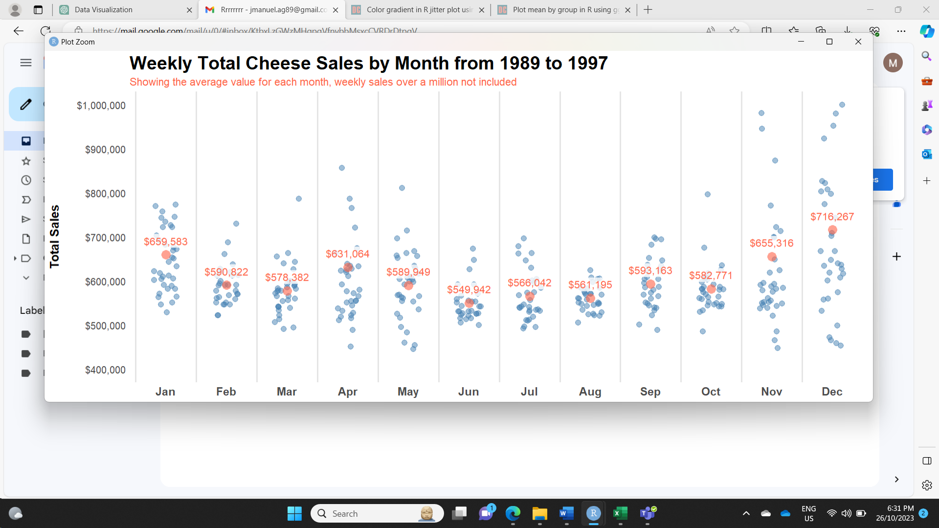

Figure , Jitter plot for the weekly sales across each month

|  |  |
| --- | --- |
| **Design information** | **Questions of interest and conclusion** |
| **Type of graphic:**  Jitter Plot with Mean Points  **Invariant:** Cheese Products  **Components:** Weekly cheese sales (Q) Monthly mean cheese sales (Q) Month (O)  **Imposition:** Orthogonal  **Planar variables:** Month (x-axis) Total Sales (y-axis)  **Retinal variables:** Position Colour to differentiate weekly sales vs mean of the month Labels to see values  **Schematic:** Labels are used to identify value of | **Can we find any differences on the average sale across each month?**  **Can we identify the top and bottom month in terms of average sales?  Are the monthly sales evenly distributed across their mean value for each month?**  First, we can identify the seasonality and difference between warmer and colder months, with colder as higher sales particularly in December. June and August are the lowest months on total sales, but what we can identify is that most of the weeks have total sale values close to their mean, in comparison December has a bigger range between lowest and highest week sale. |

# Graph 3

Figure , 100% Stacked Area Chart for distribution of Total Sales

|  |  |
| --- | --- |
| **Design information** | **Questions of interest and conclusion** |
| **Type of graphic:**  100% Stacked Area Chart  **Invariant:** Cheese Products  **Components:** Cost of Sales Percent (Q) Gross Profit Percent (Q) Week (O)  **Imposition:** Orthogonal  **Planar variables:** Week (x-axis) Percentage of Total Sales (y-axis)  **Retinal variables:** Position  Colour to differentiate "Cost of Sales" and "Gross Profit," Labels for highest and lowest   **Schematic:** Labels are used to highlight the top and bottom gross profit percentages for each year, subtitle identifies the final gross profit percentage for the entire period. | **Is the gross profit on the cheese products consistent across the timeline?**  **Is it a big range between highest and lowest value of gross profit percent?**  **Can we identify any trends?**  We can identify that the gross profit is not consistent across the years, but at the same time it doesn’t diverge much from the overall gross profit percent. At the same time we can find some outliers on both ends, with more occasions with low gross profit, this might be due to sales and specific promotions on those times of the year. |

# Graph 4

Figure , 100% Stacked Bar Chart for Gross Profit across Price Tiers

|  |  |
| --- | --- |
| **Design information** | **Questions of interest and conclusion** |
| **Type of graphic:**  100% Stacked Bar Chart  **Invariant:** Cheese Products  **Components:**  Gross Profit Percent (Q) Week (O) Year (O) Price Tier (O)  **Imposition:** Orthogonal  **Planar variables:** Week (lower x-axis), Year (top x-axis) Percentage of Total Gross Profit (y-axis)  **Retinal variables:** Position  Colour to differentiate Price Tier   **Schematic:** Subtitle identifies the final distribution of Gross Profit across the different price tiers. | **What is the distribution of gross profit percentages across different price tiers on a weekly basis?**  **How does the distribution change over the years?**  **What are the major contributors to gross profit in each week?**  We can identify that the major player on bringing most of the gross profit are the medium tier stores, this tends to be consistent across the time period we have. Now we would like to see how this compares when we look at each store individually. |

# Graph 5

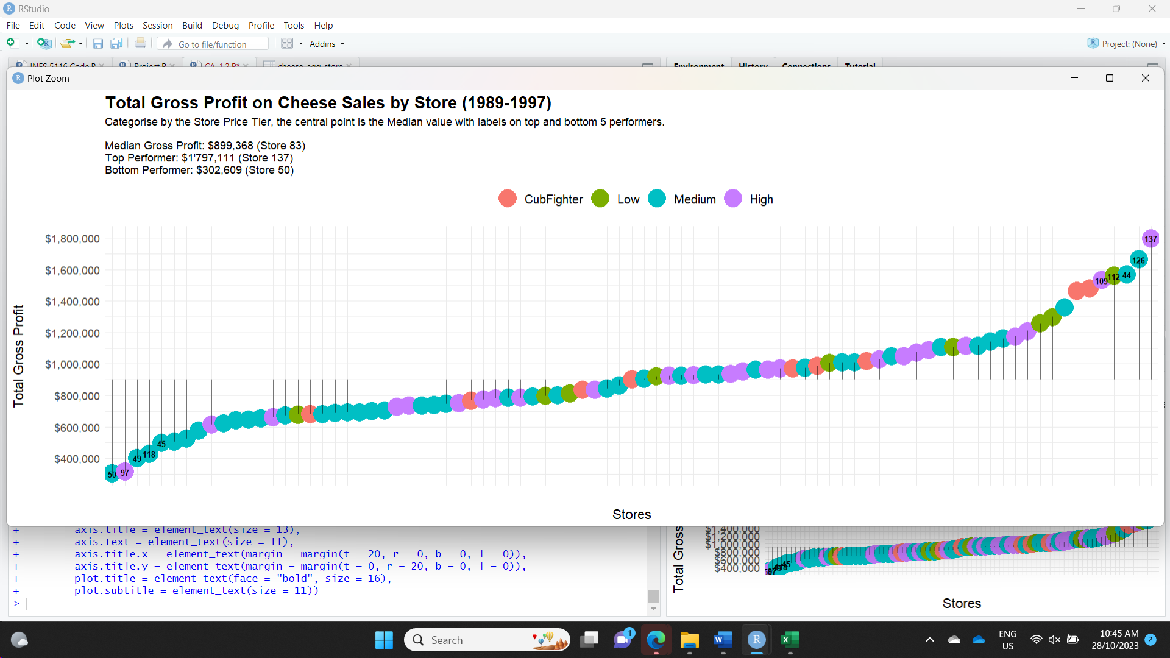

Figure , Diverging Lollipop Chart for Gross Profit across Stores

|  |  |
| --- | --- |
| **Design information** | **Questions of interest and conclusion** |
| **Type of graphic:**  Diverging Lollipop Chart  **Invariant:** Stores  **Components:**  Total Gross Profit (Q) Store (N) Price Tier (O)  **Imposition:** Orthogonal  **Planar variables:** Store (x-axis) Total Gross Profit (y-axis)  **Retinal variables:** Position  Colour to differentiate Price Tier  Labels for shops  **Schematic:** Subtitle identifies the median, top and lowest value. Labels help identify stores that generated the most and least gross profit. | **Is the gross profit evenly distributed across stores?**  **Which stores are the top and bottom performers in terms of gross profit?**  **Is there a relationship between store price tier and gross profit?**  In summary, this visualization highlights the distribution of total stores by price tier, with a majority falling into the medium price tier; while it doesn't confirm a direct link between price tier and profit, it effectively distinguishes top and bottom performers, revealing a substantial six-fold gap in gross profit between the best and worst-performing stores |

# Graph 6

Figure , Dot Plot of Total Sales vs Total Gross Profit

|  |  |
| --- | --- |
| **Design information** | **Questions of interest and conclusion** |
| **Type of graphic:**  Dot Plot  **Invariant:** Stores  **Components:**  Total Gross Profit (Q) Total Sales (Q) Price Tier (O)  **Imposition:** Orthogonal  **Planar variables:**  Total Gross Profit (x-axis) Total Sales (y-axis)  **Retinal variables:** Position  Colour to differentiate Price Tier  Labels for shops Segments across median values  **Schematic:** Median lines are drawn to divide the plot, and values are present on subtitle. Labels highlight the top and bottom 5 gross profit performers. | **Can we find a relationship between sales and gross profit?**  **Do the least profitable products also have the lowest sales?**  **Which shops perform better and worst?**  We observe a distinct and evident correlation between total sales and gross profit. Building upon the insights gained from the previous plot, we reaffirm that the shops ranking as the best and worst in terms of profitability also exhibit corresponding trends in their sales.  The plot rebels a fascinating observation: two Cubfighter shops stand out with exceptionally high sales. However, their gross profit lags significantly behind the top 5 performers. This hints at diverse pricing strategies employed by these shops.  This insight encourages us to delve deeper into the sales data of each individual shop, seeking to uncover unique patterns and variations among them. |